**EX NO.1 CREATE A DATABASE USING MS ACCESS**

**CREATING A TABLE AS STUDENT AND FIELD NAMES AS SUBJECT CODE, SUBJECT NAME , CREDITS ,GRADE.**

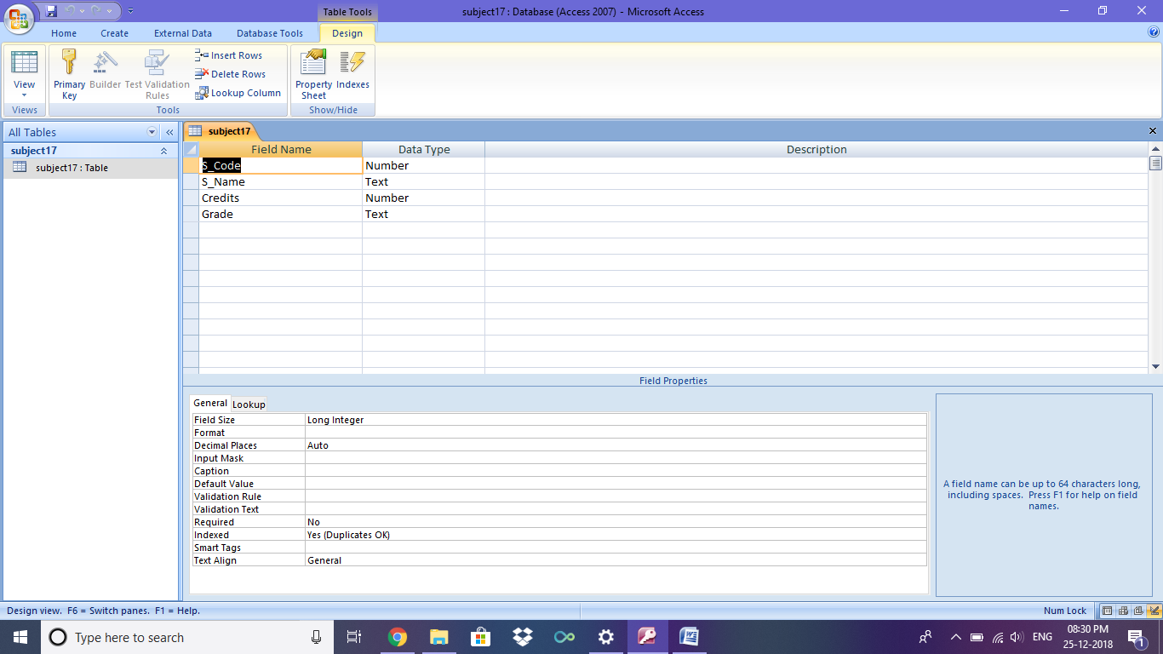

**INSERTING FIELDS TO THE CREATED TABLE**

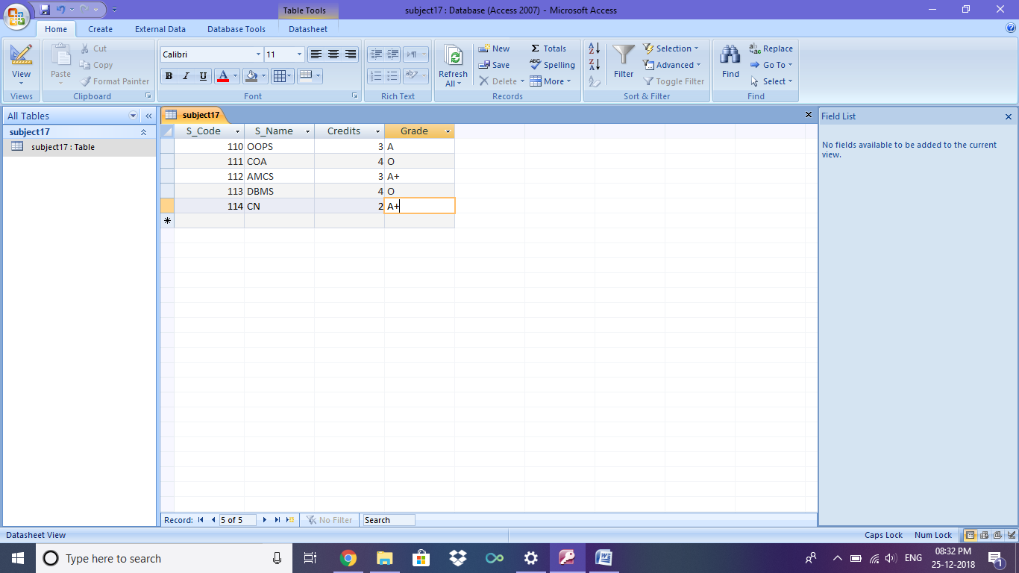

**1]. FORM VIEW - DISPLAY SUBJECT CODE , SUBJECT NAME , CREDITS**

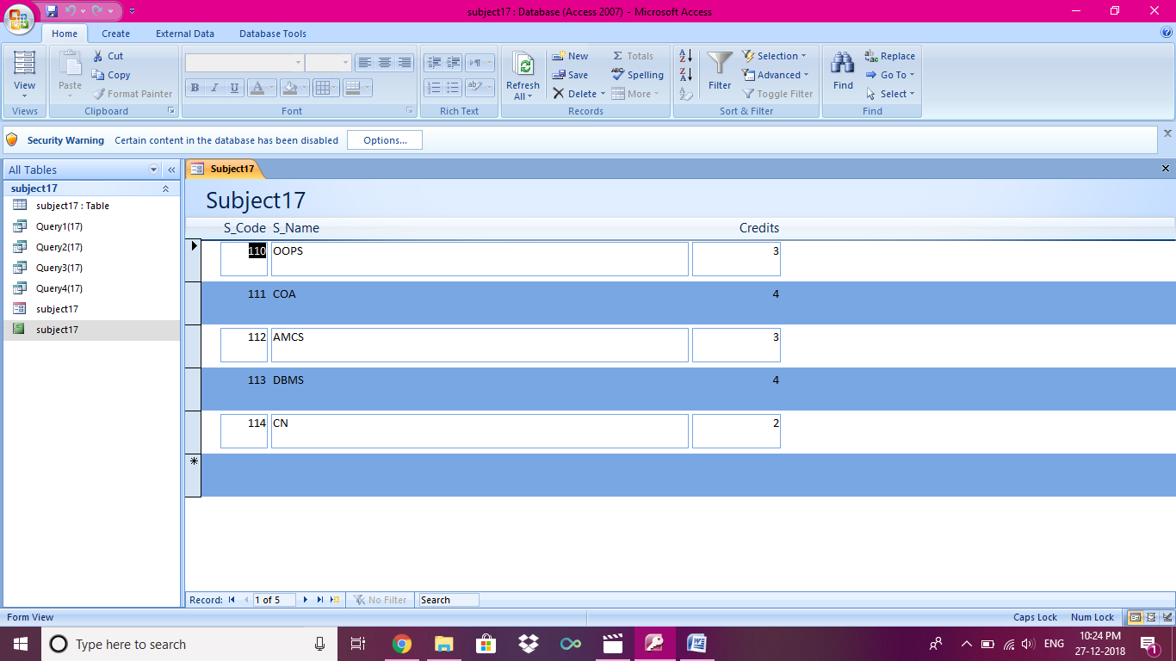

**2]. REPORT VIEW – DISPLAY ALL SUBJECT DETAILS BASED ON SUB_CODE IN CRONOLOGICAL ORDER.**

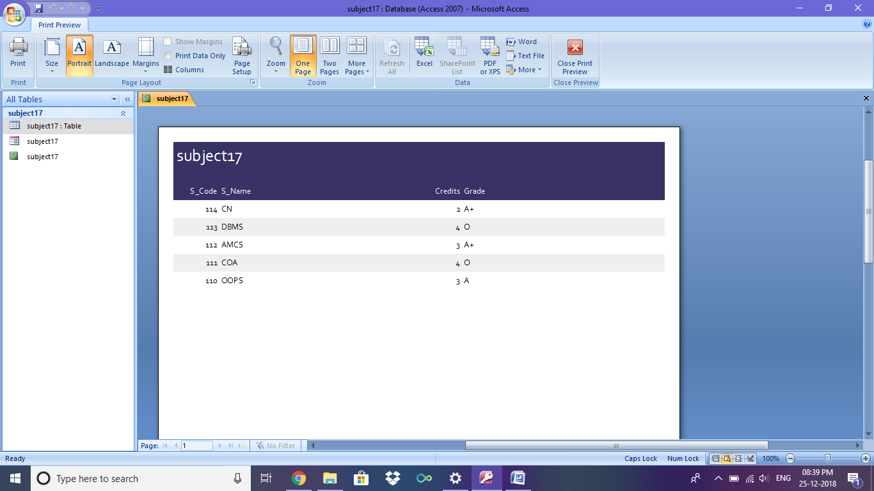

**3].QUERY DESIGN –**

**A]. DISPLAY ALL THE SUBJECT CODE AND ITS CREDITS.**

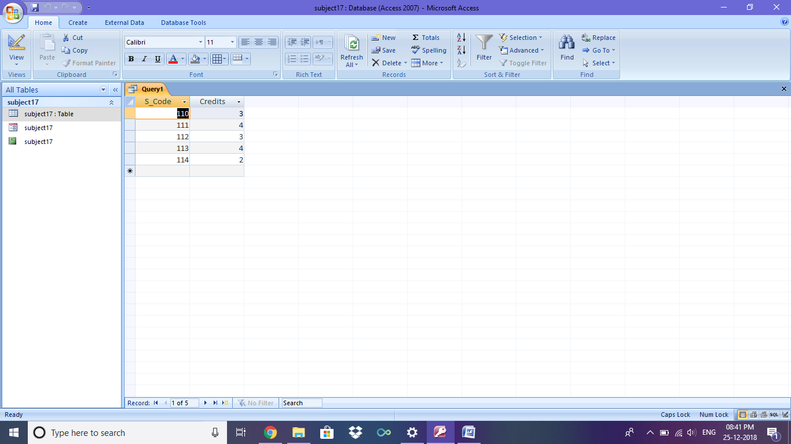

**SQL VIEW:**

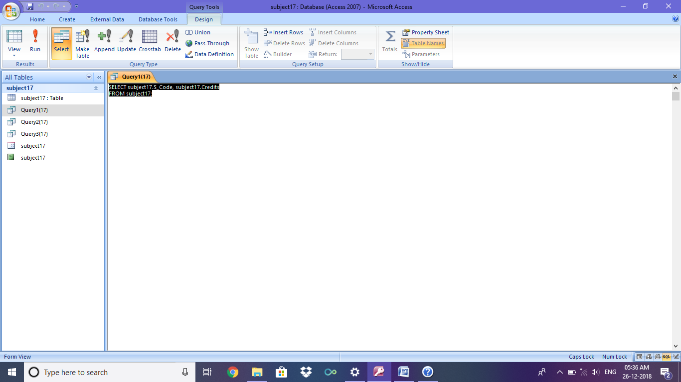

**B]. DISPLAY THE SUBJECT DETAILS WHOSE CREDIT WILL BE 4.**

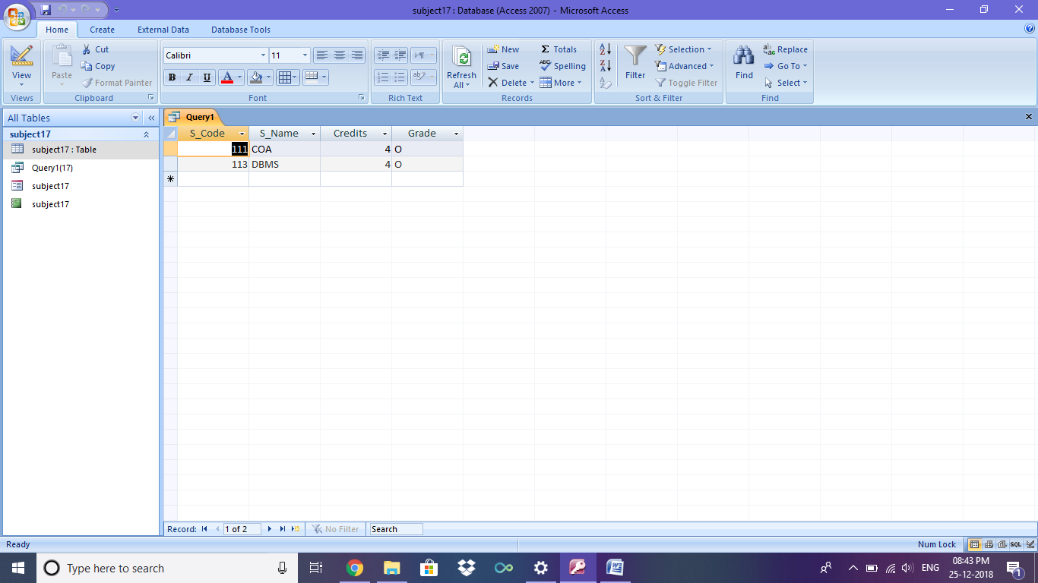

**SQL VIEW:**

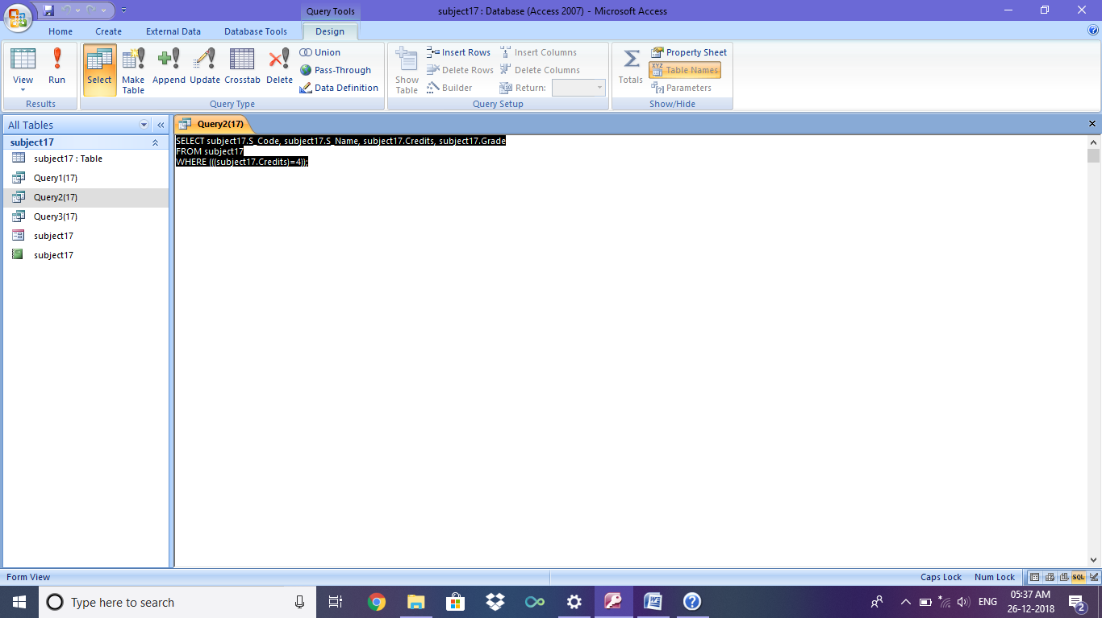

**C]. DISPLAY THE SUBJECT NAME AND A GRADE FOR A+.**

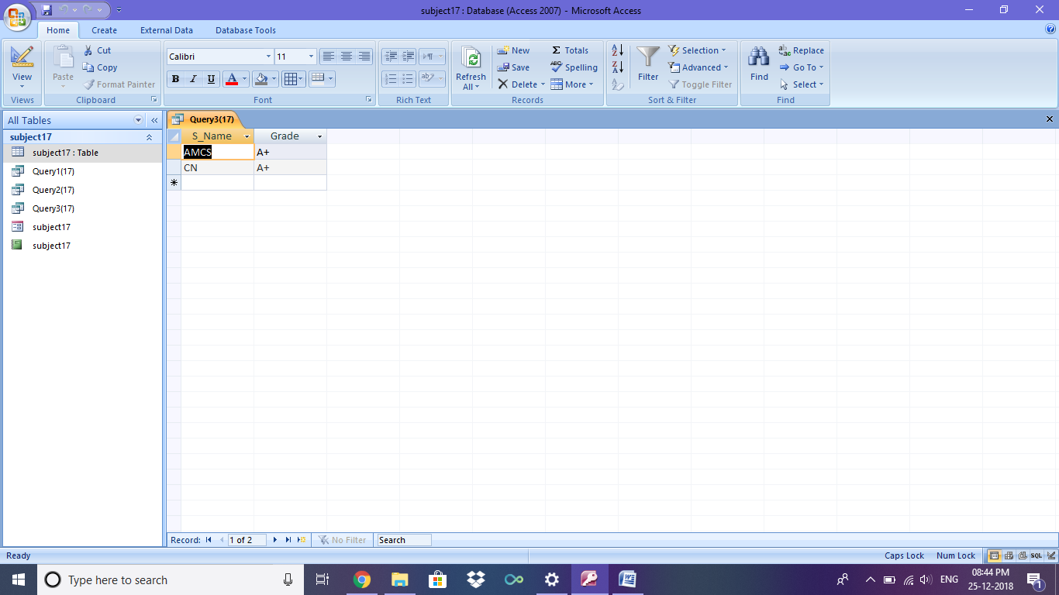

**SQL VIEW:**

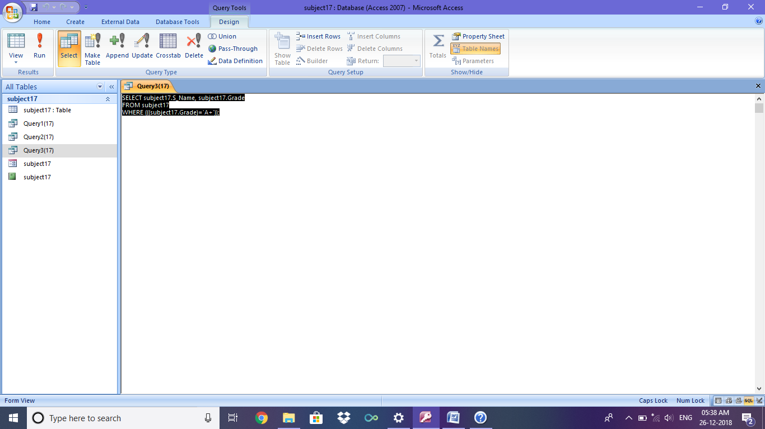

**D]. DISPLAY THE COUNT OF O GRADE.**

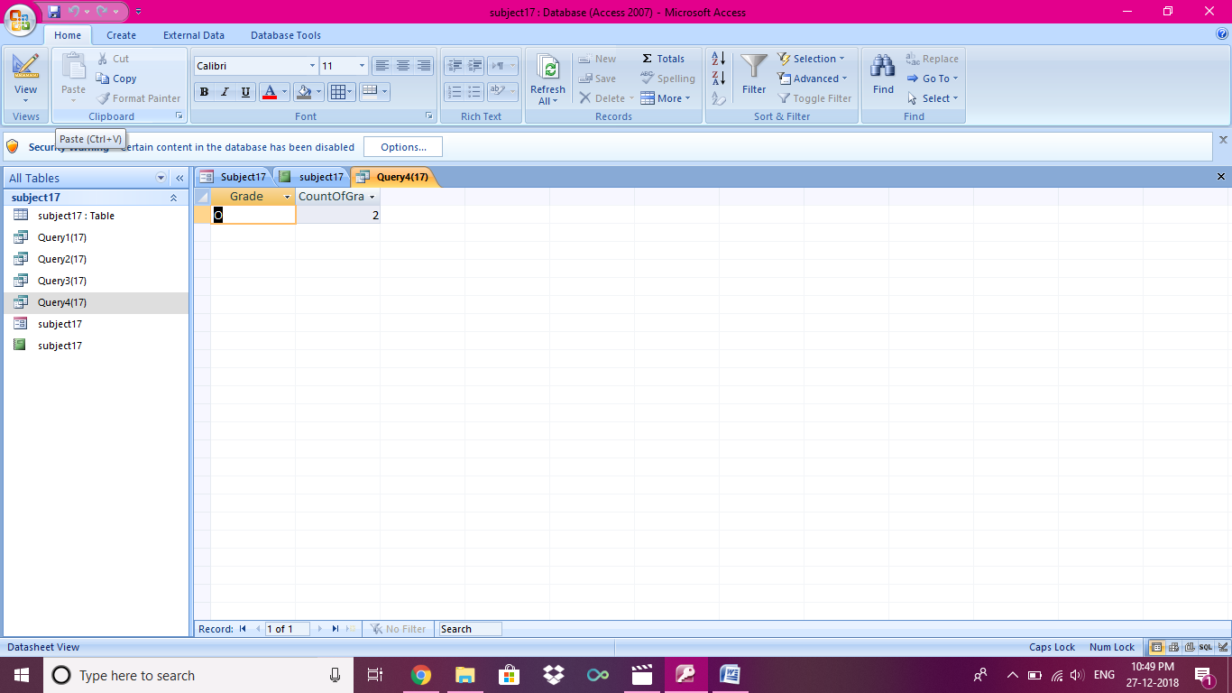

**SQL VIEW:**

